NAMAP NEWSLETTER

***Winter 2023***

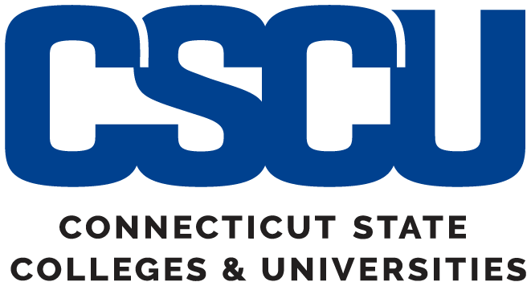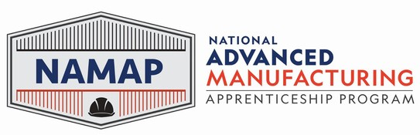

NAMAP Grant Update!

* NAMAP Updates
* Apprentice Spotlight& Apprenticeship Highlight
* Grant Partner(s) Updates
* Event Updates

### Training/Education Partners:

* Connecticut Center for Advanced Technology (CCAT),
* Manufacturing Apprenticeship Center
* Westerly Education Center (WEC)
* Quinebaug Valley Community College
* Three Rivers Community College
* Asnuntuck Community College
* Goodwin College
* New England Board of Higher Education.

### Workforce Partners:

* Connecticut Department of Labor (CTDOL)
* Eastern CT Workforce Investment Board (EWIB)
* Northwest Regional Workforce Investment Board (NRWIB)
* Sound Manufacturing Inc.

### Employer Partners:

* IBM
* General Dynamics Electric Boat
* Lockheed Martin
* Pratt & Whitney, and
* Sargent Aerospace & Defense, LLC

### NAMAP Grant Partners:

* Achieving the Dream (ATD)
* Higher Ed Insight
* National Institute of Metalworking Skills (NIMS)
* Tooling U Online Learning

### Manufacturing Associations:

* Aerospace Components Manufacturers, Inc. (ACM)
* California Manufacturing & Technology Associations (CMTA)
* Eastern Advanced Manufacturing Alliance (EAMA)
* Small Manufacturers Association of CT (SMA).

During the quarter ending on December 31, 2023, NAMAP enrolled 714 new participants, despite removing 50 participants due to the California Mobility Center (CMC) withdrawing from the project. This brought the total count to 3,022 participants, representing 86% of the target grant deliverable goal of serving 3,500 participants. Electric Boat (EB) added 164 new participants to its previous total of 591, bringing their total to more than 700 participants with 755, representing 25% of all total participants. Additionally, Lockheed Martin added 550 new participants for a total of 1,950, representing 65% of all NAMAP participants.  IBM did not add any new participants leaving their count as 62, representing 2% of all NAMAP participants, and the Eastern CT Workforce Investment Board (EWIB) remains at 255 participants, representing 8% of all NAMAP participants.

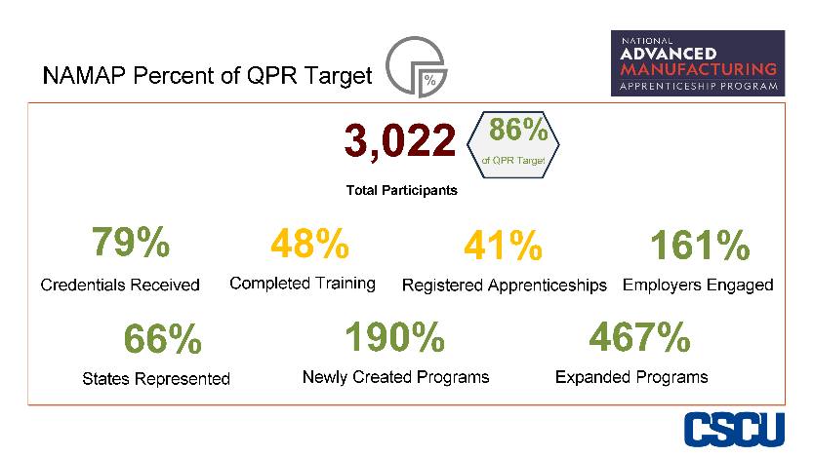Three new states, (Nevada, Tennessee, and Wisconsin), and the District of Columbia (DC) were added to the NAMAP participant pool. The NAMAP project now represents residents in 33 states, DC, and Puerto Rico. Connecticut has the largest representation of residents with 1,009 (33%) followed by Florida with the next largest representation with 717 participants (24%), Arkansas with 406 participants (13%), and Texas with 211 (7%). The remaining states where NAMAP participants reside include Alabama, Arizona, California, Colorado, Georgia, Hawaii, Kentucky, Louisiana, Maryland, Massachusetts, Michigan, Minnesota, Mississippi, New Hampshire, New Jersey, New Mexico, New York, North Carolina, Ohio Pennsylvania, Rhode Island, South Carolina, and Virginia.

Three new occupational categories were added during the quarter ending December 31, 2023, bringing the total to 52 distinct manufacturing areas being represented within the NAMAP project. The new areas include O*NET Code 15-1232.00 Computer User Support Specialists, 43-3061.00 Procurement Clerks, and 49-2094.00 Electrical and Electronics Repairers, Commercial and Industrial Equipment.  The occupational area with the largest representation continues to be O*NET code 51-2011.00 representing Aircraft Structure, Surfaces, Rigging, and Systems Assemblers with 731 apprentices (24%), followed by 51-4041.00 Machinists with 380 (13%), 17-2011.00 Aerospace Engineers with 181 (6%), 47-2152.00 - Plumbers, Pipefitters, and Steamfitters with 155 participants (5%), and 15-1252.00 Software Developers with 129 (4.3%).

## Apprentice Spotlight

## 

Before joining the Lockheed Martin team, Karl was a full-time student working in IT and cyber security. In his own words he “re-ignited” his passion for learning when he joined our apprenticeship program. It gave him a new set of tools that he uses to support a wide variety of programs at Lockheed Martin today. He credits a lot of his success in the apprenticeship program to his mentor Edward Grant, a senior systems engineer, who offered Karl knowledge in the fields of mechanical engineering, AV engineering, programming, network architecture, and Lockheed Martin as a business. Support and upkeep for the simulators at our Innovation Demonstration Center (IDC), is just one of the ways Karl is applying what he’s learned in our apprenticeship program. “I like to say that our apprenticeship program is the best return on your investment. The tools I’ve been given, and the mentoring are exactly what is needed to push my career forward,” said Karl.

“***I get a unique opportunity as an Engineering Aide to be at the forefront of showcasing products and Lockheed Martin innovation to customers not only in the United States but from all over the world”.***

Karl

## Apprentice Spotlight

Jordan embarked on his journey with IBM through the P-TECH program in Brooklyn, NY, back in 2015. Before joining P-TECH, his primary focus was on being part of the track and field team. However, realizing the potential of the P-TECH program tailored for students like him, Jordan shifted his interest to engineering and computer science. This shift marked a turning point, inspiring him to take education more seriously. In his junior year of high school, the P-TECH program opened doors for Jordan, offering him a summer internship with IBM. The P-TECH program brought a balance between work and life, allowing Jordan to pursue sports without feeling like he was missing out on his youth. Beyond computer science, the program exposed him to various opportunities, helping him discover his preference for a dynamic working environment. After completing his engineering program, Jordan is currently thriving as a Computer Engineer at IBM. Jordan's passion for problem-solving emerged during high school physics class, which was more math-intensive. Computer engineering provided a lab setting with team activities and networking opportunities. Working collaboratively on problem-solving projects, Jordan appreciated the diverse approaches each group brought to the table. This collaborative spirit remains a significant aspect of his work in IBM's systems department. Jordan acquired a range of skills, both technical and communicative. On the communication side, he honed ELA skills, including public speaking, typing, oral and written communication, note-taking, and advanced brainstorming. Technically, he developed formulaic notetaking for troubleshooting machines—a crucial skill in system maintenance. Jordan's standout moment was the opportunity to engage in volunteer work. This involved outreach in communities, teaching robotics classes, and guiding students through problem-solving processes. Continuing this practice into his career at IBM, Jordan remains dedicated to collaborating and representing IBM in the field. Jordan expresses gratitude to everyone he has networked with in school, communities, and the workplace. Above all, he acknowledges his family as his biggest supporters.

## Grant Partner(s) Update

* This quarter of the NAMAP grant has witnessed significant achievements, including the enrollment of over 700 new participants and the successful hosting of the final NAMAP Convening and Equitable Recruitment & Retention Roundtable. Moreover, we are in the final stages of completing subrecipient agreement amendments with Lockheed Martin (LM) and IBM, anticipating an increase in participants and credentialing. Sargent Aerospace has reviewed and signed the subrecipient agreement, with approval expected in the upcoming quarter. These accomplishments reflect substantial progress towards advancing the objectives of the NAMAP grant. We are committed to closing the grant strongly and meeting deliverables.
* General Dynamics Electric Boat (EB) continues to augment grant participants, incorporating 164 new participants this quarter through the Manufacturing Pipeline Initiative (MPI) pre-apprenticeship program. This program, managed by the Eastern Connecticut Workforce Investment Board, aligns with EB's substantial grant funding and future hiring needs. Adjustments to our reimbursement strategy prioritize supportive services over Related Technical Instruction (RTI), with MPI program participants receiving support ranging from $500 to $1,000, primarily for transportation, dependent care, childcare, and housing assistance.
* Although IBM did not report any participants this quarter, a subrecipient agreement amendment is nearing approval, allowing IBM to utilize the American Council of Education to add credentialing via college credits to NAMAP apprenticeship programs. Some IBM programs offer up to 48 credits towards an associate degree, removing the barrier of the high cost of higher education.
* Lockheed Martin has been a key contributor to the success of the NAMAP grant, adding 550 new participants this quarter. An amendment introducing $1,000,000 in funding for Related Technical Instruction will be approved next quarter, enabling Lockheed Martin to add up to 800 new participants. This expansion underscores the high projections for apprentice enrollment in the grant's final phases.
* NAMAP signed on a new partner Sargent Aerospace & Defense LLC. Sargent Aerospace & Defense is a medium-sized employer in Arizona that agreed to the terms of our subrecipient agreement. The agreement is currently being circulated internally at CSCU for signature and approval. With a contract valuation below $25,000, the subrecipient agreement will not require approval from the Office of the Attorney General (OAG). The Sargent subrecipient agreement will be valued at $24,980, including the training of 20 participants. Sargent is collaborating with NIMS to develop an unregistered apprenticeship program for training Machinists in Milling and Lathe.
* NAMAP and NIMS have proven to be innovative and valuable. NIMS has generously shared its network to help us identify additional employer partners. Currently, NIMS is collaborating with Sargent Aerospace in Arizona to develop an unregistered apprenticeship program for Machining, which aims to train 25 or more participants. If discussions continue to progress positively, NAMAP should be able to support and add Sargent Aerospace as a subrecipient.
* California Mobility Center (CMC) has formally withdrawn from the NAMAP grant due to a shift in leadership direction. Consequently, we have removed the 50 participants from the NAMAP grant, and we will proceed without CMC's support.
* Higher Ed Insight successfully delivered the Year 4 Evaluation Report. The primary objective of this evaluation was to assess program implementation and outcomes, as well as to identify promising practices and lessons that can enhance program improvement efforts. Notably, this report marked the first instance of incorporating qualitative data from active grant participants. Previous reports had exclusively included quantitative data from participants, along with qualitative data from grant stakeholders. Through in-depth interviews with participants, Higher Ed Insight was able to draw comprehensive conclusions regarding the strengths and weaknesses of NAMAP apprenticeships, particularly those associated with Lockheed Martin and IBM.
* Pratt & Whitney (PW) continues to experience the most challenges due to COVID-19. PW, a subsidiary of Raytheon, is an aerospace manufacturer with stakes in both the commercial and defense aerospace industry. COVID-19 has caused a massive reduction in commercial airline travel, which has had a significant impact on PW and its parent company Raytheon. In October of 2020, Raytheon announced 20,000 layoffs across their business units with as many as 450 layoffs from PW's Connecticut locations. With the current COVID-19 challenges facing PW, the grant expects some of its 259 participants to be utilized in other apprenticeship programs. Although challenges continue, the airline industry is beginning to rebound. Future commercial airline travel may provide an opportunity for PW to join the grant.

## Events Update

* On November 15, 2023, NAMAP hosted its second in-person grant convening at CT State Community College @ Asnuntuck in Enfield, CT. The event was hybrid and was attending be all grant partners. The event celebrated the grant highlights and continued the final Equitable Recruitment and Retention Roundtable. Participants enjoyed an engaging discussion surrounding a racial equity assessment tool, created by the organization Race Forward.

***This program is funded by or in part by an $8,000,000 Scaling Apprenticeship Through Sector-Based Strategies grant from the U.S. Department of Labor, Employment and Training Administration. This program is an Equal Opportunity Employer/program.***